PUBLIC NOTICE

Please take notice that members of the Evans City Council will be attending the Town Hall Meeting event on Thursday, February 13, 2025 beginning at 6:00 p.m. in the Cottonwood Room at the Evans Community Complex, 1100 37th Street, Evans, CO 80620.

At least three members of the City Council expressed interest in attending this meeting.
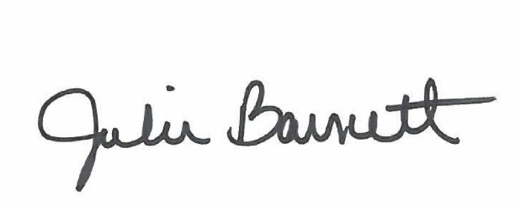

______________________________________
Julie Barnett, City Clerk
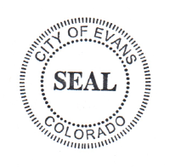
Posted: February 10, 2025

